Major Project

# All the patients are female

import pandas as pd

df=pd.read_csv('https://raw.githubusercontent.com/2k0v11/Dataset/main/diabetes.csv.csv')

df

# Here the output will be outcome and input will be Pregnancies, Glucose, BloodPressure, SkinThickness, Insulin, BMI, DPF, Age

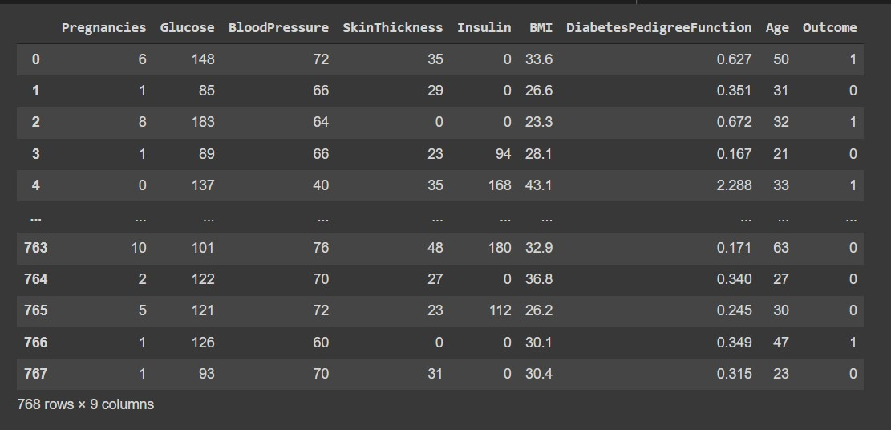

x=df.iloc[:,[0,1,2,3,4,5,7]].values

x

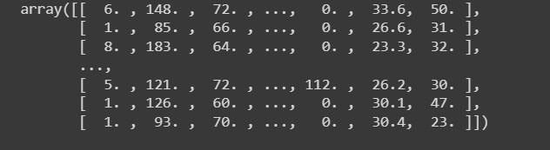

y=df.iloc[:,-1].values

y

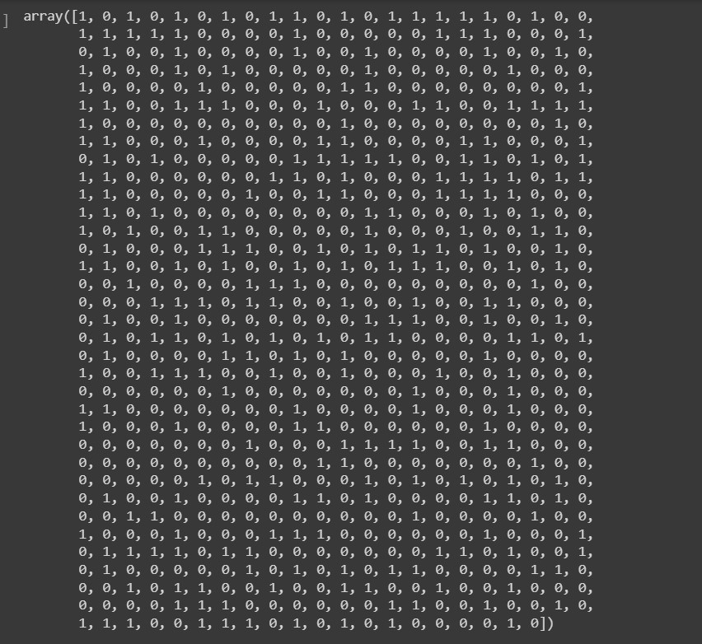

from sklearn.model_selection import train_test_split

x_train,x_test,y_train,y_test=train_test_split(x,y,random_state=0)

print(x.shape)

print(x_train.shape)

print(x_test.shape)



print(y.shape)

print(y_train.shape)

print(y_test.shape)



from sklearn.preprocessing import MinMaxScaler

scaler = MinMaxScaler()

x_train = scaler.fit_transform(x_train)

x_test = scaler.fit_transform(x_test)

from sklearn.linear_model import LogisticRegression

model=LogisticRegression()

model.fit(x_train,y_train)



ypred=model.predict(x_test)

ypred

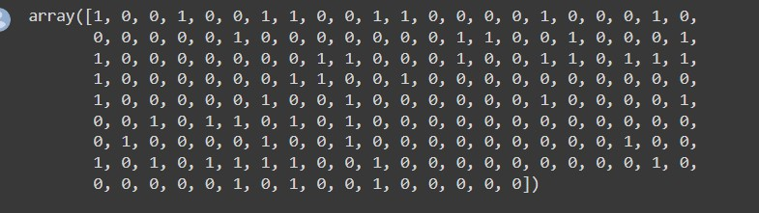

y_test

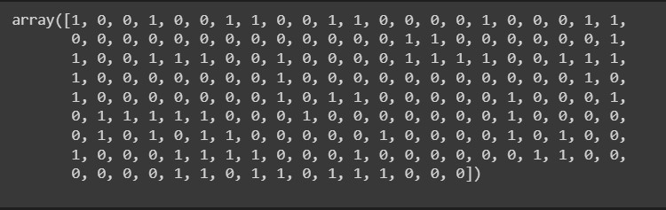

from sklearn.metrics import accuracy_score

accuracy_score(ypred,y_test)*100



model.predict([[1,200,180,24,200,41,19]]



* Link for the group project performed on google collab: <https://colab.research.google.com/drive/1fBNhddEdNcqb6BF52IQSGMe-dHMbYw0e?usp=sharing>

**Submitted By : Kavya Kartik (kavyakartik6@gmail.com)**